**SECTION 6**

**HEARIACHEY LEVEL**

select level id,name,deptid

from emp

start with id=100

connect by prior id=deptid;

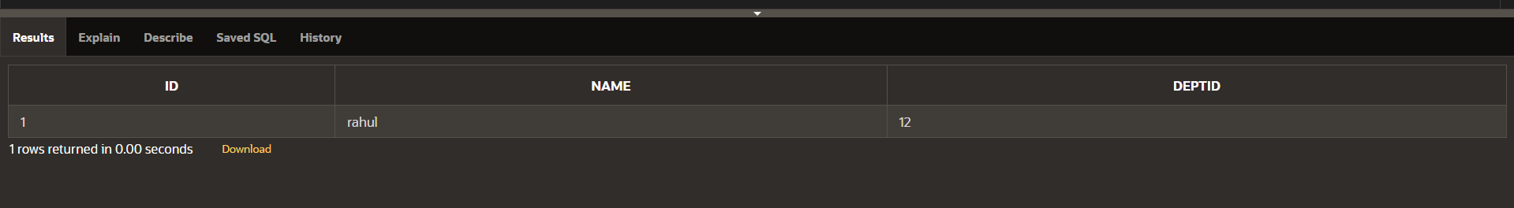

**HIERACHIAL USING START WITH KEYWORD**

select id,name,deptid

from emp

start with id=100

connect by prior id=deptid;

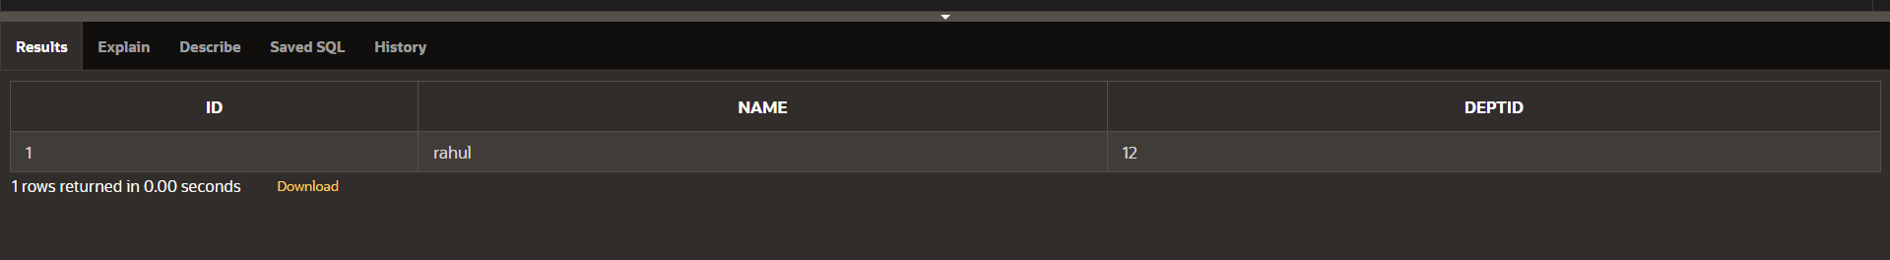

**FULL OUTER JOIN**

select e.id,e.name,d.deptid,d.dept_name

from emp e full outer join dept d

on (e.deptid=d.deptid);

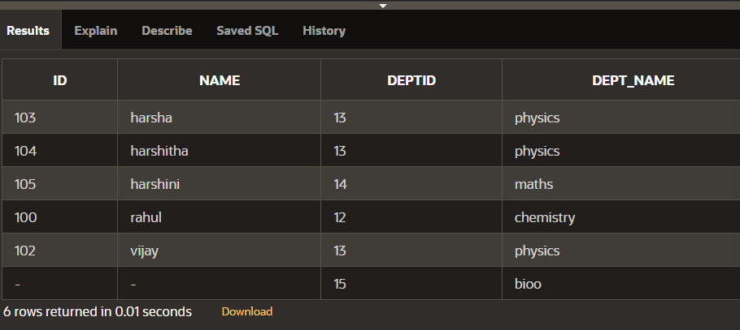

**RIGHT OUTER JOIN**

select e.id,e.name,d.deptid,d.dept_name

from emp e right outer join dept d

on (e.deptid=d.deptid);

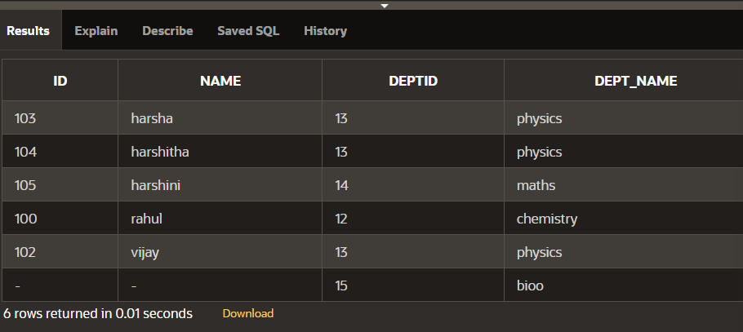

**LEFT OUTER JOIN**

select e.id,e.name,d.deptid,d.dept_name

from emp e left outer join dept d

on (e.deptid=d.deptid);

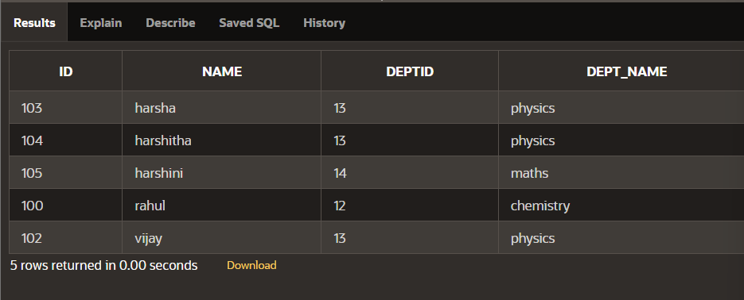

**ON CLAUSE**

select id,name,dept_name

from emp e join dept d

on(e.deptid=d.deptid);

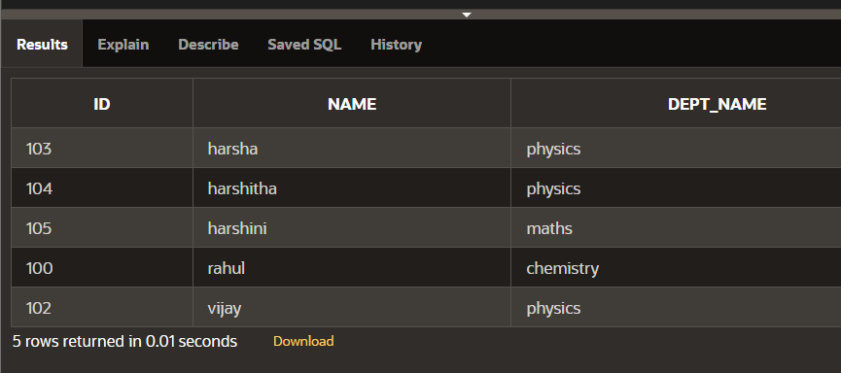

**USING CLAUSE**

select id,name,deptid,dept_name

from emp join dept using (deptid);

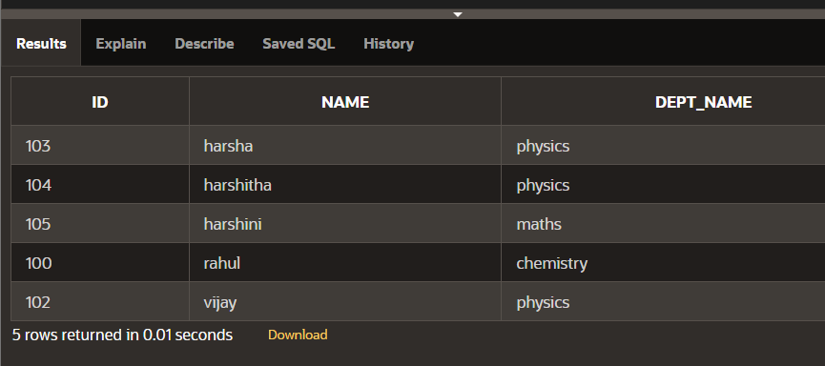

**CROSS JOIN**

select id,name,dept_name

from emp cross join dept;

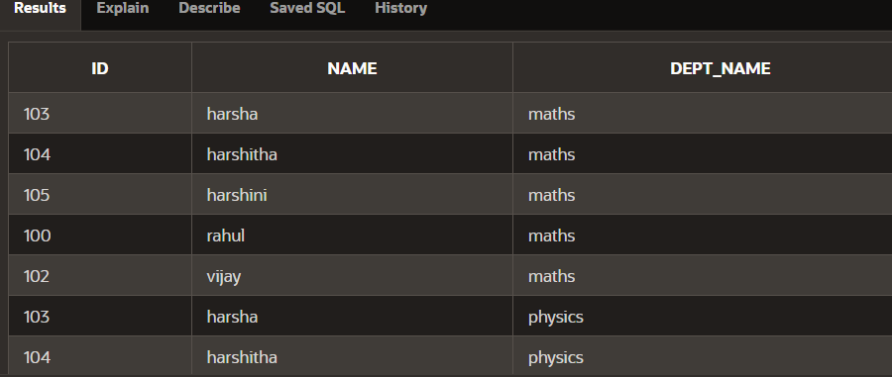

**NATURAL JOIN**

select id,name,deptid,dept_name

from emp natural join dept;

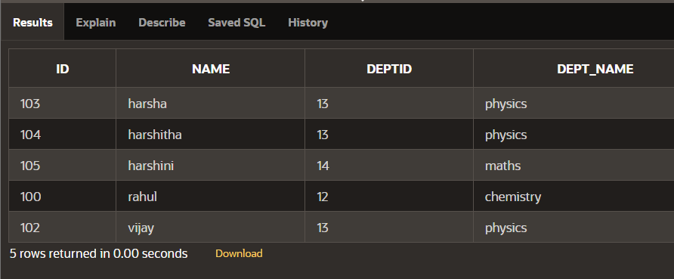

**SECTION 5**

**NVL FUNCTION**

select id,nvl(dept,'not assigned')

from singer;

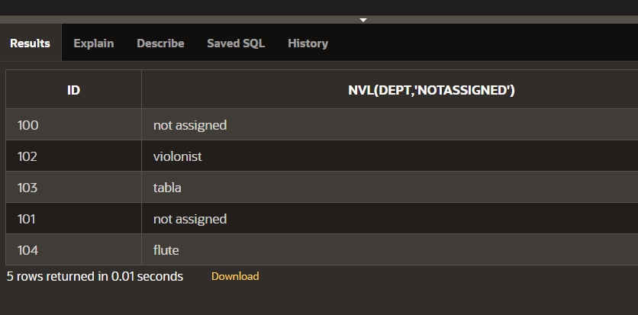

**NVL DATE**

SELECT NVL(TO_CHAR(hiredate, 'YYYY-MM-DD'), 'no date')

FROM singer;

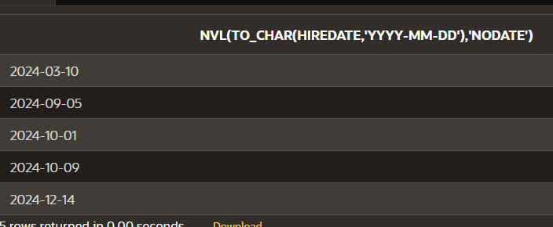

**CHARACTER TO DATE**

select to_date('may10,1989','fxmondd,yyyy') as "convert"

from dual;

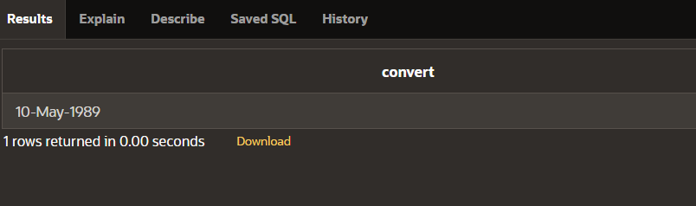

**NUMBER TO CHARACTER**

select to_char(salary,'$99,999')

from singer;

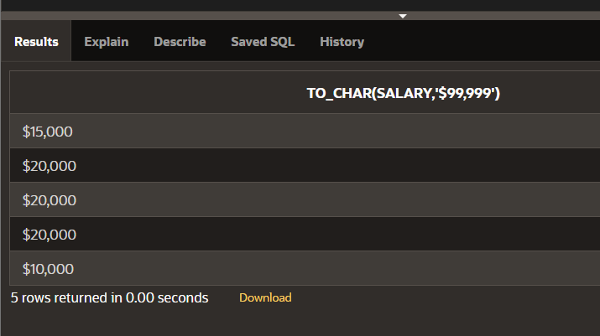

**DATE TO CHARACTER**

select to_char(hiredate,'month dd,yyyy')

from singer;

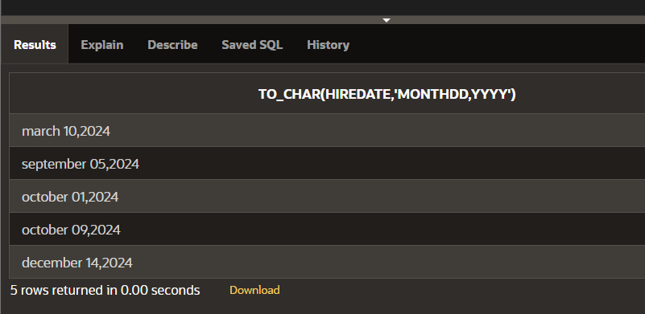

**DATE FUNCTION**

select id,name,hiredate,round(months_between(sysdate,hiredate)) as tenure, add_months(hiredate,6) as review, next_day(hiredate,'friday'),last_day(hiredate)

from singer;

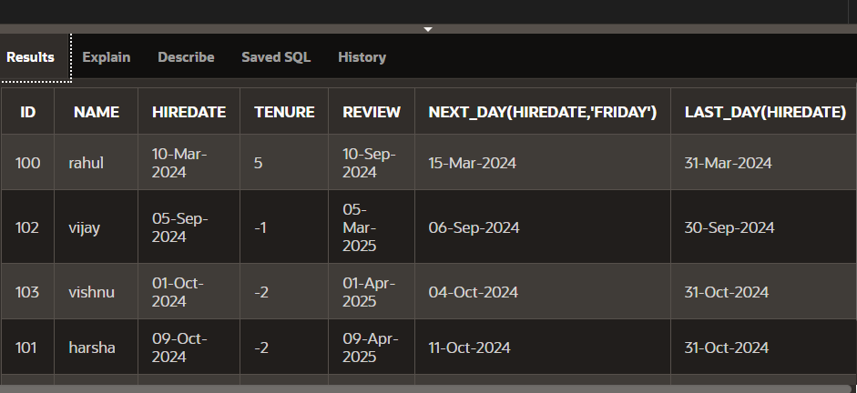

**SECTION 4**

**TRUNC**

select hiredate,

trunc(hiredate,'month')

from singer;

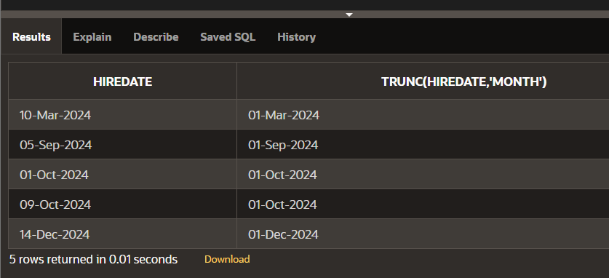

**ROUND TO HIREDATE**

select hiredate,

round(hiredate,'month')

from singer;

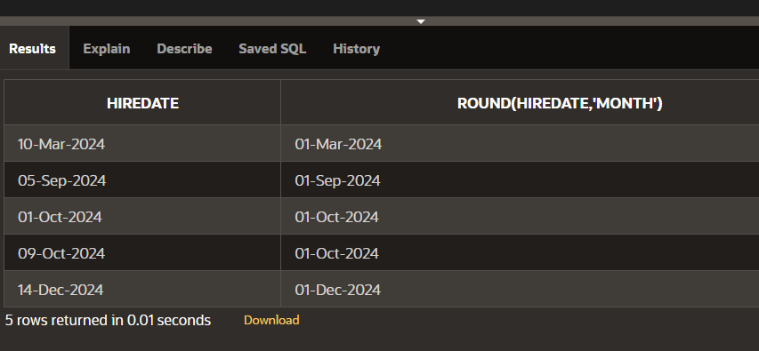

**LAST DAY**

select last_day(sysdate)

from dual;

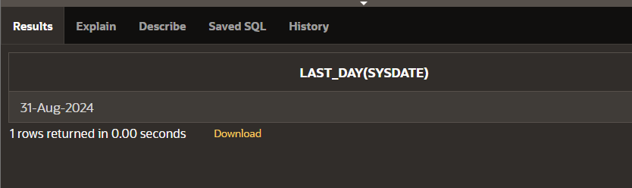

**NEXT DAY**

select next_day(sysdate,'monday')

from dual;

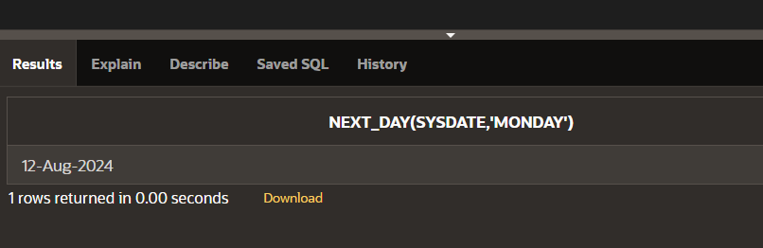

**ADD MONTHS**

select add_months(sysdate,5)

from dual;

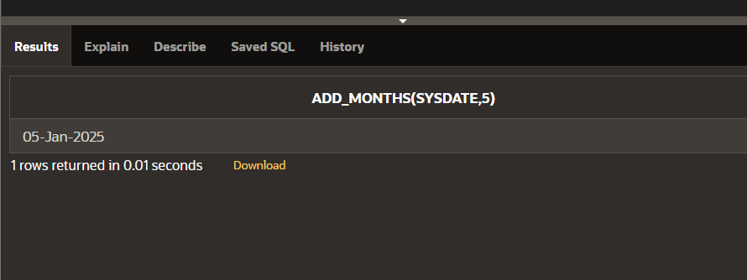

**MONTHS BETWEEN**

select id,name

from singer

where months_between

(sysdate,hiredate)<100;

